Steps to setup Sublime + VSCode in Mac m1

1. Install sublime from <https://www.sublimetext.com/download>. Also, in parallel download VSCode stable version from <https://code.visualstudio.com/>
2. After installation move both of them in Applications folder
3. Open VSCode and install the following 2 extensions:

Note: The first one is C/C++ official extension and the second one is Code runner

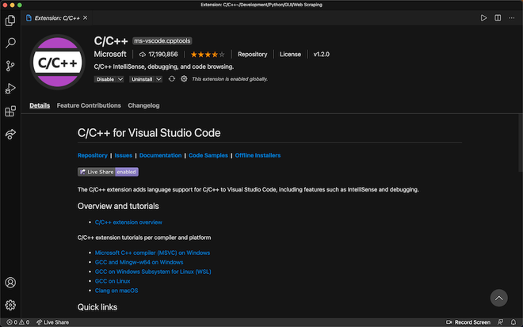

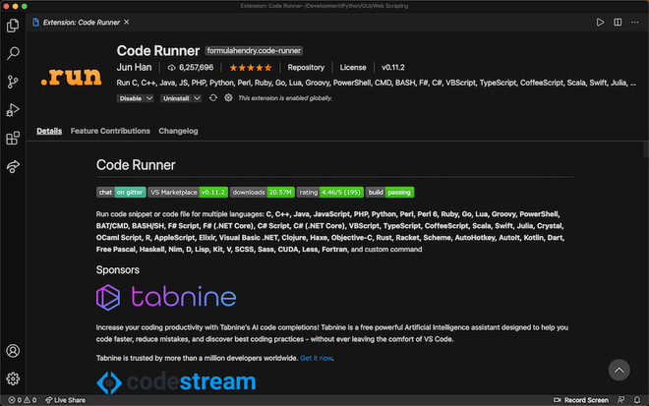

1. Install homebrew by running the following command:

/bin/bash -c "$(curl -fsSL <https://raw.githubusercontent.com/Homebrew/install/HEAD/install.sh>)"



1. Execute the following in sequence:

- Run these three commands in your terminal to add Homebrew to your **PATH**:

echo '# Set PATH, MANPATH, etc., for Homebrew.' >> /Users/riteshranjannahak/.zprofile

echo 'eval "$(/opt/homebrew/bin/brew shellenv)"' >> /Users/riteshranjannahak/.zprofile

eval "$(/opt/homebrew/bin/brew shellenv)"

- Run **brew help** to get started



1. Install mingw-w64 by running the following command:

brew install mingw-w64



1. Setting up bits/stdc++.h header file:

cd /; cd opt/homebrew/include; mkdir bits; vim stdc++.h

After creating a file just copy the code from the [GitHub repository](https://github.com/Archies13Singh/cpp-important-packages-file/blob/main/stdc++.h) and paste that code into stdc++.h file and then press Esc followed by “:wq”

Comment out line 57, 61 and 131

1. Add the environment variable to .zprofile (or file corresponding to shell like ~/.bash_profile)

export CPATH=/opt/homebrew/include

export LIBRARY_PATH=/opt/homebrew/lib

1. Open Sublime Text and install Package Control under Tools option. After the download and installation is successful, install the following packages and complete the necessary configuration: (Side Bar is available as SideBarEnhancement)

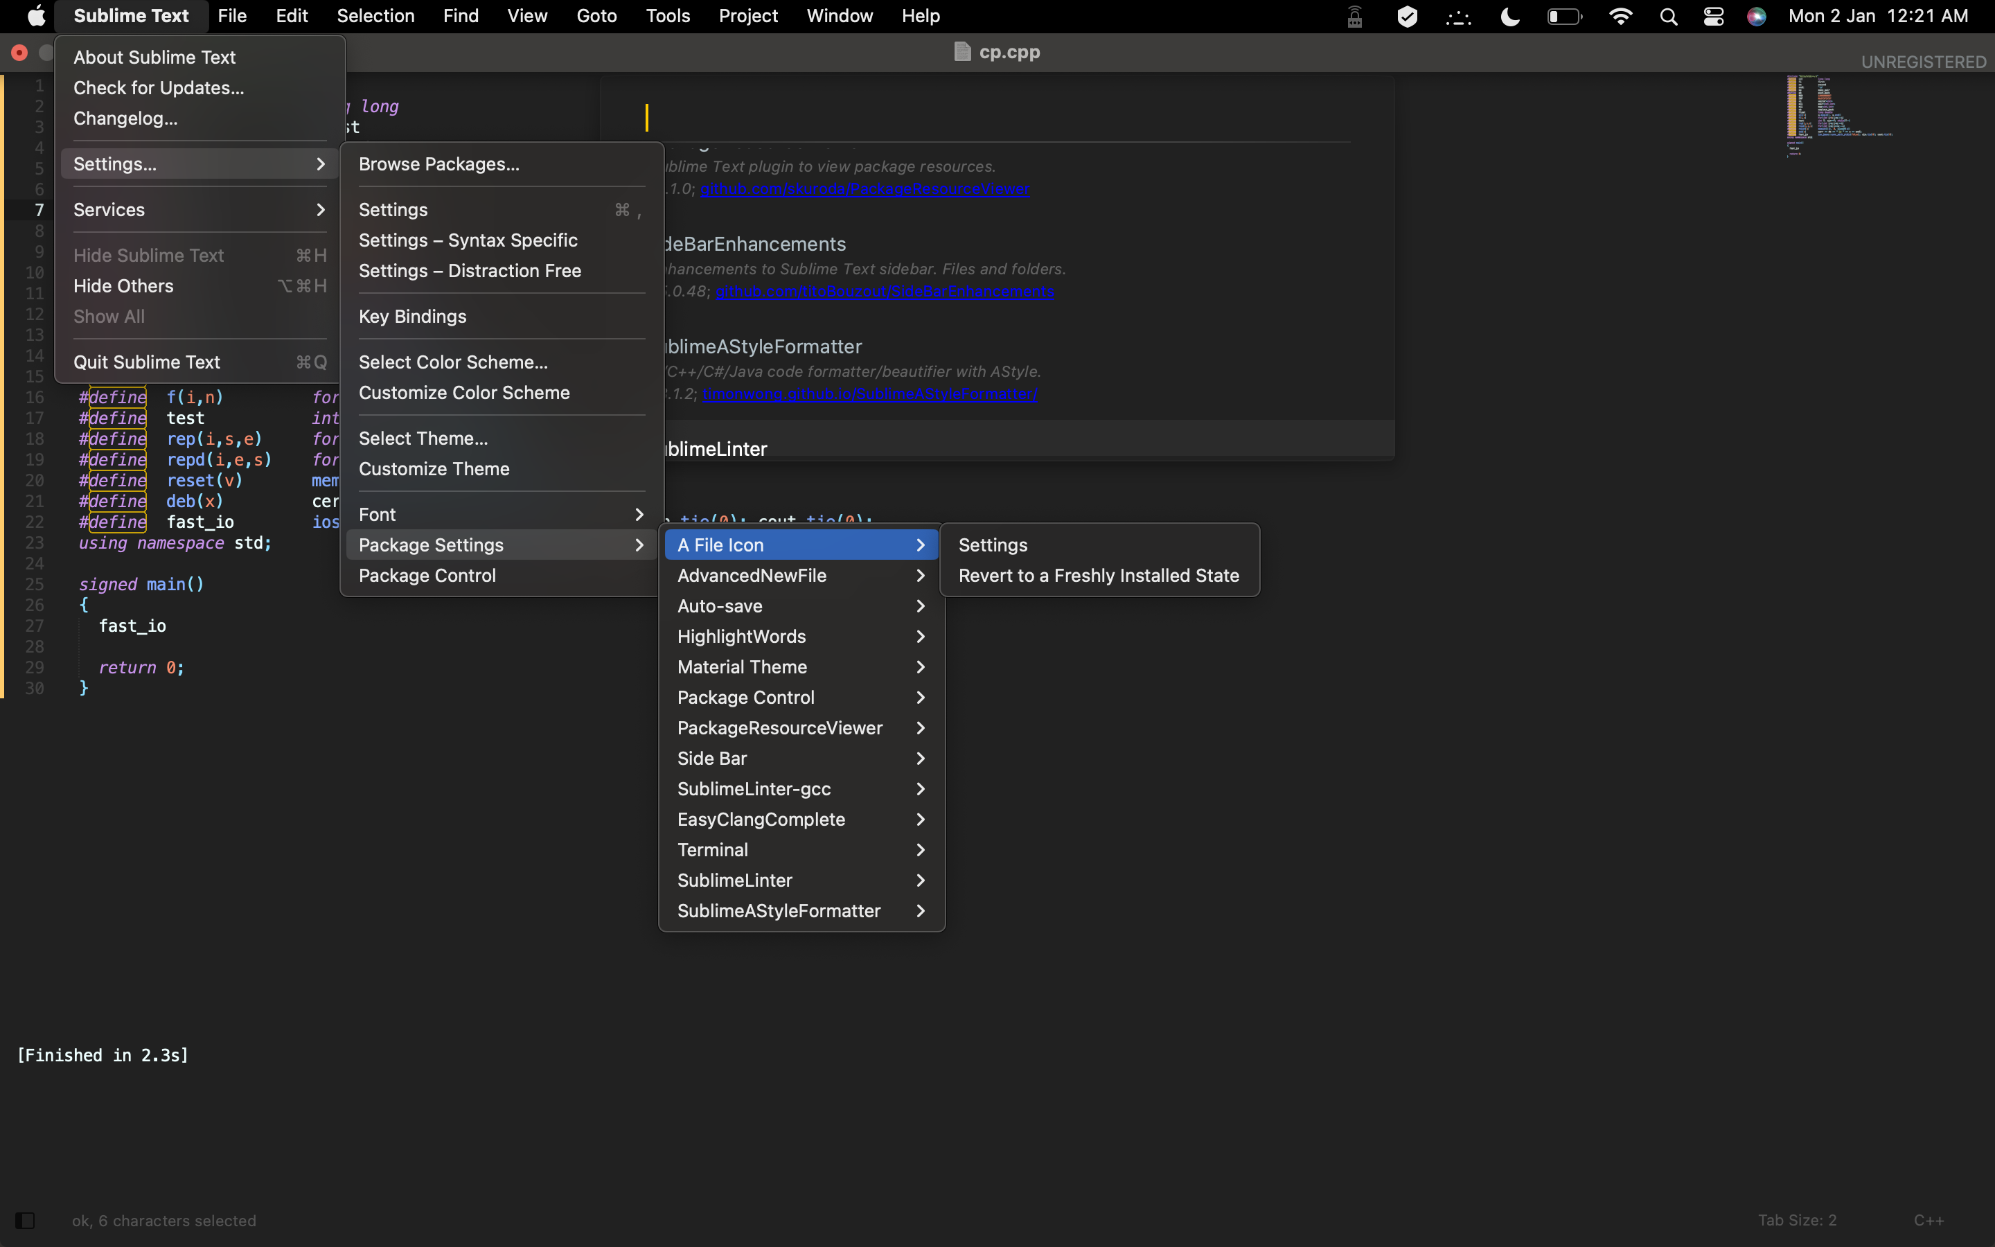

1. Setting auto formatting in C++:

To install, in Sublime, Tools << Command Palette and type install package and then type SublimeAStyleFormatter and it will be installed in a moment.

Now to use this plugin,

Restart Sublime, got to Preferences << Package Settings << SublimeAStyleFormatter << Settings — User and add the following code and save the file…

{

"autoformat_on_save": true

}

Restart Sublime and see the magic of SublimeAStyleFormatter in your C++ file.

Note:

I was facing issue with my m1 mac. Now it is resolved. What I did was open sublime text using Rosetta. Some of the sublime packages started working for me as I changed sublime text to open using Rosetta, when I click.

Follow these steps.

1. Quit Sublime text.
2. Go to Applications.
3. Right click on Sublime Text -> Get Info -> Select "Open using Rosetta" checkbox.
4. Open sublime Text again and check.

This resolved the issue for me. However, in case you do not want to go through Rosetta for sublime, then you can have Clang format Sublime Package installed; that works natively, without going through Rosetta.

1. Add the snippets files from the following [GitHub link](https://github.com/nriteshranjan/Sublime-Snippets) under:

riteshranjannahak/Library/Application Support/Sublime Text/Packages/User/ folder

1. Add the below build system and save it with “C++” name:

{

"shell_cmd": "g++ -std=c++17 \"${file}\" -o \"${file_path}/${file_base_name}\"",

"file_regex": "^(..[^:]*):([0-9]+):?([0-9]+)?:? (.*)$",

"working_dir": "${file_path}",

"selector": "source.c, source.c++",

"variants":

[

{

"name": "Run",

"shell_cmd": "g++ -std=c++17 \"${file}\" -o \"${file_path}/${file_base_name}\" && \"${file_path}/${file_base_name}\""

}

]

}

1. In Sublime Text, under **View**, change indentation to Tab Width: 4
2. Create a C++ file and run the code using C++ build system (not the run one!):



#include <bits/stdc++.h>

using namespace std;

int main()

{

int a= 2, b=4;

cout<<a+b<<endl;

return 0;

}

// save above as cp.cpp

Now press Cmd + Shift + t to open terminal in that folder and execute the following command:

